
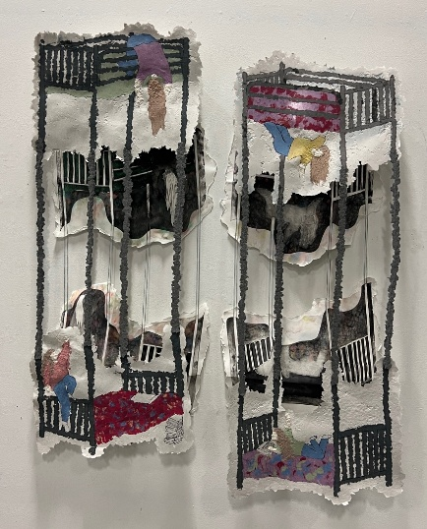
Basic Papermaking

Supply List
Instructor: Brookelle Robertson

Students will learn how to recycle paper into paper pulp. They will then learn a variety of techniques including casting, sculpting, and making sheets.

Supplies Provided by Mark Arts:
- Recycled paper
- Blenders
- Acrylic Paint
- Bins for water vats
- Plexi glass

Supplies Student will Purchase:
- Supply some silicone/ chocolate molds
- Old blenders if they have one
- Wire for armatures
- Frames/ screens (Variety of sizes)
- Bins for water vats (Large enough to fit frames/screens)
- Plexi glass

To purchase screens:

Amazon.com: Caydo 4 Pieces 4 Size Screen Printing Frame with 110 Mesh for Screen Printing Beginners and Kids, 9 x 5.1 Inch, 10.6 x 6.7 Inch, 12.2 x 8.2 Inch, 14 x 10 Inch

