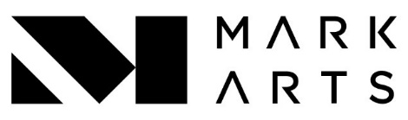
Abstract Painting
Ages 16+ | Instructor: Matthew Hilyard
Course Objectives: Learn how to talk about your and fellow students' work. Experience a new way of approaching non-objective painting. Engage in discussions on how you the artist see the world around you and translate that to the work. Explore past and current Contemporary Artists.
Course Description: Explore past and current trends in nonobjective painting, exploring acrylic, water-based media, and drawing with collage. Students work at their own pace on personal projects with instructor guidance. All experience levels are welcome, and experimentation will be encouraged.
Student Supply List:
- Acrylic paint (any colors)
- Any size Board, Paper or Canvas
- Blue shop towels
- Wide brushes - 2" or more
- Scrapers
- Large and small Trowel set (Lowes, Walmart in the painting section)
- Hair dryer and extension cord 6ft or more
- Pencils, Markers, Pastels, any mark-making tools.
- 2- 12" x 12" Board, Canvas or Paper (for first day of class)
- Scissors
Course Schedule:
Week 1: Class introductions. Small format paintings and Quick class critique from the instructor.
Week 2: Instructor one-on-one with each student.
Week 3: Class painting and class critiques.
Week 4: Class painting and critiques. Student engagement with fellow Artists about their works in class.
Week 5: Class painting and critiques. Student engagement with fellow Artists about their works in class.
Week 6: Class painting and critiques.
Week 7: Class painting and critiques.
Week 8: Class painting and critiques.
Week 9: Class painting and critiques
Week 10: Class painting and critiques with focus on individual students from instructor about the session.

