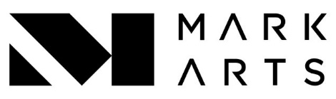
Abstract Painting
Tuesday 1- 3pm
Instructor name:
Jim Gross
Title of class or workshop:
Afternoon Abstract
Art Medium:
painting
Student skill level (circle all that apply): Beginning, intermediate, or advanced
All levels of students combined in one class
Course Description (4-6 sentences):
Explore past and current trends in nonobjective painting, exploring acrylic, water-based media and drawing with collage. Students work at their own pace in an independent study learning environment on personal projects with guidance from Jim. All experience levels are welcome, and experimentation will be encouraged.
Goals:

Supply List
- Basic acrylic paint set
  - Blue, yellow, red, white.
- Large brushes (1”-1.5”)
- Rags/paper towels
- Canvas boards or Masonite
- Drawing pencil or charcoal

