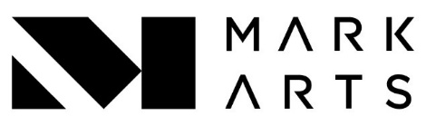
Mixed Media
Instructor: Gayle Bryson Clayborn
Course Objectives: Learn how to mix watercolor and pastel, colored pencils, oils, pastels, and everything in between.
Course Description: Lapidary artists will bring stones for optional purchase. Advanced process possibilities include – casting, hydraulic press use, and other stone-setting methods, to name a few.
Supply List:
Colored Pencils
Pastels
Watercolor
Oil Paints

