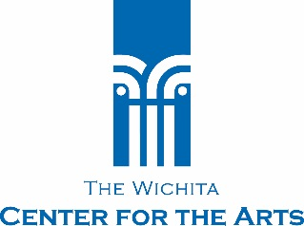

FOR IMMEDIATE RELEASE: May 20, 2016
Contact: Katy Dorrah
Wichita Center for the Arts
316-634-2787
katy@wcfta.com
Wichita Center for the Arts Presents Mary R. Koch School of Visual Arts Student Exhibition
_______________________________________________________________________
Best of Show and Other Award Winners Announced
WICHITA, Kan. —Wichita Center for the Arts announces its Mary R. Koch School of Visual Arts Student Exhibition, which will be on display May 20 - June 26.
The exhibit features 336 works by 132 of the Center’s student artists. Each quarter, more than 250 artists of all ages and skill levels study with the Center’s accomplished faculty. Jurors selected $100 scholarship winners in 10 mediums and named one Best of Show.
Best of Show: Thomas Montgomery for Bar Sign
Jewelry and Metalsmithing: Bruce Chapin for Gecko Bracelet
Drawing: Marc North for Tim Stone
Abstract: Curt Hutchens for Ascension
Acrylic: Pam Bjork for Ode to Turner
Sculpture: Angie Wormhoudt for Jenae
Watercolor: Nancy Luttrell for The Old Mill
Oil: Sharon Zimmerman for Bee & Blossoms
Printmaking: Caitlin Penny for The Mists
Enameling: Jennifer Walterscheid for Blue Longhorn Beetle (Callophophora Solli) on Orange Leaf
Ceramics: Bill Koch for Another Anger Bowl
Jurors were professional artists Connie Ernatt and John Ernatt, who own The Diver Studio on Commerce Street, and Dimitris Skliris, the Center’s director of exhibitions.
An opening reception is planned for 5 - 7 p.m. Friday, May 20, featuring a cash bar and complimentary light hors d’oeuvres.
###
About Wichita Center for the Arts
The Center’s mission is to be a vibrant arts hub in Wichita and the region by providing opportunities to appreciate, participate and create art in an atmosphere of lifelong learning. It was originally founded in 1920 as the Wichita Art Association and is the area’s oldest visual arts organization. The gallery is open 1 to 5 p.m. Tuesday through Sunday. Admission is free. Visit wcfta.com or call 316.634.2787.

